Year 11 > 12
KS5 Taster Session
Name: ………………………………………………..
Problem: To determine the concentration of a sodium hydroxide solution using 0.1 mol/dm-3 hydrochloric acid.

Balanced Equation:
NaOH + HCl → NaCl + H₂O

Keywords

Acids : Acids form acidic solutions in water. Acids produce hydrogen ions, H⁺ in aqueous solution. Acidic solutions have pH values less than 7.

Alkalis: Alkalis form alkaline solutions in water. Alkalis produce hydroxide ions, OH⁻ in aqueous solution. Alkaline solutions have pH values greater than 7.

Neutral solutions: A neutral solution is neither acidic, nor alkaline. A neutral solution has a pH value of 7.

Indicators and the pH scale: The pH scale measures the acidity or alkalinity of a solution. The pH of a solution can be measured using a pH probe, or estimated using universal indicator and a colour chart. Indicators such as phenolphthalein or methyl orange.

To determine the concentration of a sodium hydroxide solution using 0.1 mol/dm-3 hydrochloric acid.
This required practical involves using appropriate apparatus to make and record a range of measurements accurately, including volume of liquids. It also involves determining the concentration of one of the solutions in mol/dm³ and g/dm³.
It is important in this practical to:
- make and record accurate measurements
- take account of health and safety considerations

Aims
- To determine the reacting volumes of solutions of an acid and alkali by titration.
- To determine the concentration of one of the solutions in mol/dm³ and g/dm³ (Higher tier only).

The required apparatus is:
- burette
- pipette and filler
- conical flask and white tile

The reagents are:
- an acid (hydrochloric, sulfuric or nitric) of unknown concentration
- sodium hydroxide solution of known concentration
- a suitable indicator, for example methyl orange or phenolphthalein

Hazards, risks and precautions
Identify the hazards and suggest precautions needed to reduce the risk of harm. For example:
Hazard | Possible harm | Precaution
Dilute sodium hydroxide solution | Causes skin and serious eye irritation | Wear gloves and eye protection, and use a pipette filler
Spilling hydrochloric acid while filling the burette | Causes eye irritation | Fill the burette slowly below eye level, using a funnel
This table does not include all the possible hazards.

Carrying out the practical
- Use the pipette and pipette filler to add 25 cm³ of alkali to a clean conical flask.
- Add a few drops of indicator and put the conical flask on a white tile.
- Rinse the burette through with acid. Fill the burette with acid and note the starting volume. Use a funnel to help
- Slowly add the acid from the burette to the alkali in the conical flask, swirling to mix.
- Stop adding the acid when the end-point is reached (when the indicator first permanently changes colour). Note the final volume reading.
- Repeat steps 1 to 5 until you get concordant titres ( results with 0.1cm³ of each other) More accurate results are obtained if acid is added drop by drop near to the end-point.

Tasks
Label the equipment
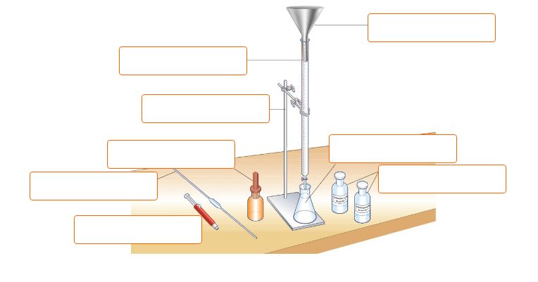

Complete the steps
- Rinse the burette with acid. Place the burette in the clamp with the_______________ at the bottom
- Check the tap is off and fill the b______________ with acid using the f__________________.
- Make sure the _________________ is removed from the burette. Record the reading on the __________
- Use the ___________to measure 25cm³ alkali into a conical flask. Add a few drops of _____________.
- Place the __________flask under the burette on a white tile
- Add a small amount of ______at a time to the alkali in the conical flask. _________ the conical flask
- When the _____________ point is nearing, add the acid a ____________ at a time.
- When the indicator changes colour, stop adding acid and write down the reading on the____________.
- Repeat the titration until you have ____________ results (three results that are within 0.1cm³ of each other)
Result table:
Run | Initial | Final | Titre
Rough
1
2
3
Average Titre (cm3)

Problem: To determine the concentration of a sodium hydroxide solution using 0.1 mol/dm⁻³ hydrochloric acid.

3 steps to work out concentration of sodium hydroxide.

NaOH + HCl → NaCl + H₂O

Equation used: Moles = concentration (mol/dm³) x volume used (dm³)
- 1000cm³ = 1dm³

example below uses a hypothetical average titre of 23.82 cm³.
- 23.82 cm³ = 0.02382 dm³
1000

Step 1: Get moles from burette (0.1 mol/dm³ HCl solution)
- Moles = concentration x volume used (dm³)
substitution
- Moles = 0.1 x 0.02382dm³
- Moles of HCl from burette = 0.002382

Step 2: Get moles in flask
- 1 mol HCl neutralises 1 mol NaOH
- 0.002382 mol NaOH in flask

Step 3: Get concentration in flask
- Moles = concentration x volume used
rearrange
- Concentration = moles from burette
volume used
substitution
- Concentration = 0.002382
0.025
- Concentration = 0.09528 mol/dm3
Concentration of NaOH was 0.095 mol/dm³
Your turn:
Use your results to complete the 3 steps to work out concentration of sodium hydroxide.

NaOH + HCl → NaCl + H₂O

Equation used: Moles = concentration (mol/dm³) x volume used (dm³)
- 1000cm³ = 1dm³

Average titre is _____________ cm³. Average titre is _____________ dm³.

Step 1: Get moles from burette – 0.1 mol/dm³ HCl solution

- Moles = concentration x volume used (dm³)
- Moles = 0.1 x ( __________ cm³/1000)
- Moles – 0.1 x ___________________dm³
- Moles of HCl from burette = ____________________

Step 2: Get moles in flask

- 1 mol HCl neutralises 1 mol NaOH
- ____________________ mol NaOH in flask

Step 3: Get concentration in flask

- Concentration = moles from burette
volume used (dm³)
- Concentration = ______________
0.025
- Concentration = ___________________ mol/dm3
Concentration of NaOH was __________ mol/dm³

Exam Practice
This question is about acids and alkalis.
(a) Which ion do all acids produce in aqueous solution?
Tick (✓) one box.

H⁺
H⁻
O²⁻
OH⁻
(1)
(b) Calcium hydroxide solution reacts with an acid to form calcium chloride.
Complete the word equation for the reaction.
calcium hydroxide + ___________________ acid → calcium chloride + ___________________
(2)

A student investigates the volume of sodium hydroxide solution that reacts with 25.0 cm³ of dilute sulfuric acid.
Figure 1 shows the apparatus the student uses.
Figure 1
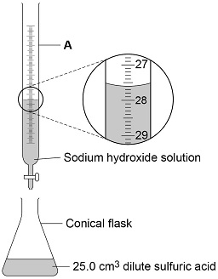
Use Figure 1 to answer parts (c) and (d).
(c) Name apparatus A.
___________________________________________________________________
(1)
(d) What is the reading on apparatus A?
___________________________cm³
(1)
(e) The higher the concentration of a sample of dilute sulfuric acid, the greater the volume of sodium hydroxide needed to neutralise the acid.
The student tested two samples of dilute sulfuric acid, P and Q.
Describe how the student could use titrations to find which sample, P or Q, is more concentrated.
___________________________________________________________________
___________________________________________________________________
___________________________________________________________________
___________________________________________________________________
___________________________________________________________________
___________________________________________________________________
___________________________________________________________________
___________________________________________________________________
___________________________________________________________________
___________________________________________________________________
___________________________________________________________________
___________________________________________________________________
(6)
(Total 11 marks)
Exam Question
Sodium hydroxide reacts with hydrochloric acid.
The diagram shows apparatus that can be used to find the volume of sodium hydroxide reacting with 25.0 cm ³ hydrochloric acid.
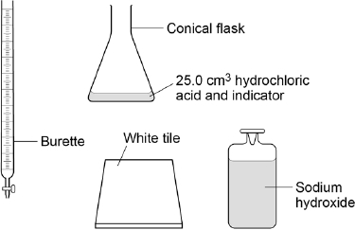
Describe a method to find the exact volume of sodium hydroxide that reacts with 25.0 cm ³ of hydrochloric acid.
___________________________________________________________________
___________________________________________________________________
___________________________________________________________________
___________________________________________________________________
___________________________________________________________________
___________________________________________________________________
___________________________________________________________________
___________________________________________________________________
___________________________________________________________________
___________________________________________________________________
___________________________________________________________________
___________________________________________________________________

(6)

